Home Work SQL

Question 1 a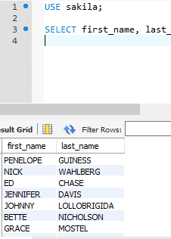

USE sakila;

SELECT first_name, last_name FROM actor;

Question 1b

SELECT first_name, last_name, concat(first_name," ", last_name) AS Actor_Name

FROM actor;

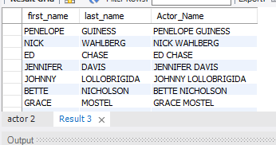

Question 2a

USE saklia;

SELECT actor_id, first_name, last_name

FROM actor

WHERE upper(first_name) like 'Joe%';

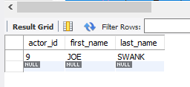

-- Question 2b

USE sakila;

SELECT last_name

FROM actor

WHERE last_name LIKE '%GEN%';

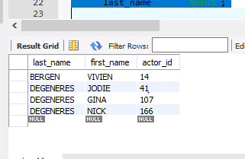

-- Question 2c

USE Sakila;

SELECT last_name, first_name

FROM actor

WHERE last_name LIKE '%LI%'

ORDER BY last_name, first_name;

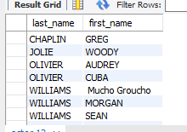

-- Question 2d

USE Sakila;

SELECT country_id, country

FROM country

WHERE country IN ('Afghanistan', 'Bangladesh', 'China');

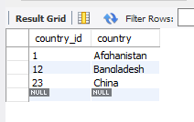

-- Question 3a

USE Sakila;

alter table actor drop column actor.middle_name;

ALTER TABLE actor

ADD COLUMN middle_name blob after first_name;

select * from actor;

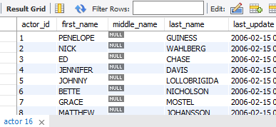

-- Question 3b

ALTER TABLE actor

MODIFY middle_name BLOB;

-- Question 3c

ALTER TABLE actor

DROP COLUMN middle_name;

-- 4a. List the last names of actors, as well as how many actors have that last name.

SELECT last_name, COUNT(last_name)

Count(*)

FROM actor

GROUP BY last_name;

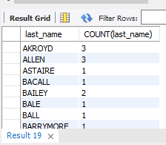

-- 4b. List last names of actors and the number of actors who have that last name, but only for names

-- that are shared by at least two actors

SELECT last_name, COUNT(*) as A

FROM actor

GROUP BY last_name

HAVING COUNT(last_name) >=2;

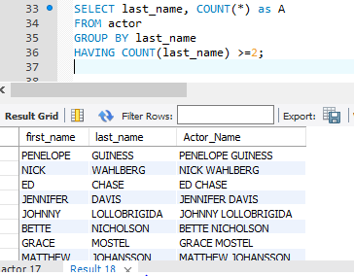

-- 4c. Oh, no! The actor HARPO WILLIAMS was accidentally entered in the actor table as

-- GROUCHO WILLIAMS, the name of Harpo's second cousin's husband's yoga teacher.

-- Write a query to fix the record.

UPDATE actor

SET first_name = 'Harpo'

WHERE first_name = 'GROUCHO' AND last_name like 'WILLIAMS';

-- 4d. Perhaps we were too hasty in changing GROUCHO to HARPO. It turns out that

-- GROUCHO was the correct name after all! In a single query, if the first name of the actor is currently

-- HARPO, change it to GROUCHO. Otherwise, change the first name to MUCHO GROUCHO, as that

-- is exactly what the actor will be with the grievous error. BE CAREFUL NOT TO CHANGE THE FIRST NAME

-- OF EVERY ACTOR TO MUCHO GROUCHO, HOWEVER! (Hint: update the record using a unique identifier.)--

UPDATE actor

SET first_name = 'MUCHO GROUCHO'

AND last_name like 'William'

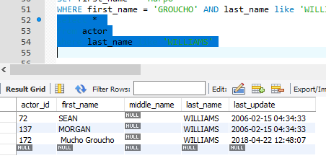

-- 5a. You cannot locate the schema of the address table. Which query would you use to re-create it?

SHOW CREATE TABLE sakila.address;

-- CREATE TABLE `address` (

-- `address_id` smallint(5) unsigned NOT NULL AUTO_INCREMENT,

-- `address` varchar(50) NOT NULL,

-- `address2` varchar(50) DEFAULT NULL,

-- `district` varchar(20) NOT NULL,

-- `city_id` smallint(5) unsigned NOT NULL,

-- `postal_code` varchar(10) DEFAULT NULL,

-- `phone` varchar(20) NOT NULL,

-- `location` geometry NOT NULL,

-- `last_update` timestamp NOT NULL DEFAULT CURRENT_TIMESTAMP ON UPDATE CURRENT_TIMESTAMP,

-- PRIMARY KEY (`address_id`),

-- KEY `idx_fk_city_id` (`city_id`),

-- SPATIAL KEY `idx_location` (`location`),

-- CONSTRAINT `fk_address_city` FOREIGN KEY (`city_id`) REFERENCES `city` (`city_id`) ON UPDATE CASCADE

-- ) ENGINE=InnoDB AUTO_INCREMENT=606 DEFAULT CHARSET=utf8

-- 6a. Use JOIN to display the first and last names, as well as the address, of each staff member. Use the

-- tables staff and address:

SELECT first_name, last_name, address

FROM staff,address

where staff.address_id = address.address_id;

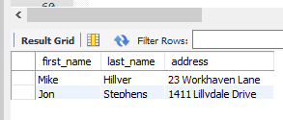

-- 6b. Use JOIN to display the total amount rung up by each staff member in August of 2005. Use tables

-- staff and payment.

SELECT first_name, last_name, SUM(payment.amount)

FROM staff, payment

Where staff.staff_id = payment.staff_id

AND month(payment_date) = 8

Group by staff.staff_id

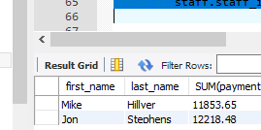

-- 6c. List each film and the number of actors who are listed for that film. Use tables film_actor and film.

-- Use inner join.

SELECT title, COUNT(actor_id)

FROM film f

INNER JOIN film_actor fa

ON f.film_id = fa.film_id

GROUP BY title;



-- 6d How many copies of the film Hunchback Impossible exist in the inventory system?

SELECT title, COUNT(inventory_id)

FROM film f

INNER JOIN inventory i

ON f.film_id = i.film_id

WHERE title = "Hunchback Impossible";

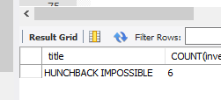

-- 6e. Using the tables payment and customer and the JOIN command, list the total paid by each customer. List the customers alphabetically

-- by last name:

SELECT last_name, first_name, SUM(amount)

FROM payment p

INNER JOIN customer c

ON p.customer_id = c.customer_id

GROUP BY p.customer_id

ORDER BY last_name ASC;

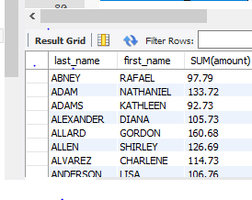

-- 7a. The music of Queen and Kris Kristofferson have seen an unlikely resurgence. As an unintended consequence, films starting

-- with the letters K and Q have also soared in popularity. Use subqueries to display the titles of movies starting with the letters K and Q whose

-- language is English.

USE Sakila;

SELECT title FROM film

WHERE language_id in

(SELECT language_id

FROM language

WHERE name = "English" )

AND (title LIKE "K%") OR (title LIKE "Q%");

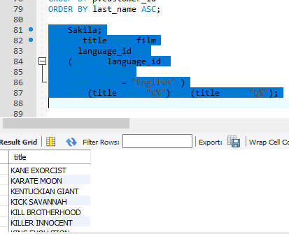

-- 7b. Use subqueries to display all actors who appear in the film Alone Trip.

use sakila;

select fl.actor_id, ac.first_name, ac.last_name

from actor ac

join film_actor fl on ac.actor_id = fl.actor_id

join film fm on fl.film_id = fm.film_id

where fm.title like 'Alone Trip' ;

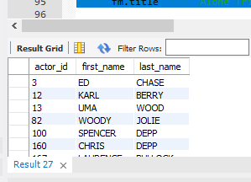

-- 7c. You want to run an email marketing campaign in Canada, for which you will need the names and email addresses of all Canadian customers.

-- Use joins to retrieve this information.

USE Sakila;

SELECT country, last_name, first_name, email

FROM country c

LEFT JOIN customer cu

ON c.country_id = cu.customer_id

WHERE country = 'Canada';

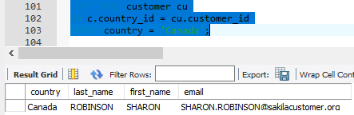

-- 7d. Sales have been lagging among young families, and you wish to target all family movies for a promotion. Identify all movies

-- categorized as family films.

USE Sakila;

SELECT title, category

FROM film_list

WHERE category = 'Family';

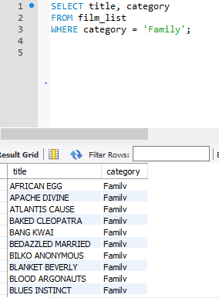

-- 7e. Display the most frequently rented movies in descending order.

USE Sakila;

SELECT i.film_id, f.title, COUNT(r.inventory_id)

FROM inventory i

INNER JOIN rental r

ON i.inventory_id = r.inventory_id

INNER JOIN film_text f

ON i.film_id = f.film_id

GROUP BY r.inventory_id

ORDER BY COUNT(r.inventory_id) DESC;

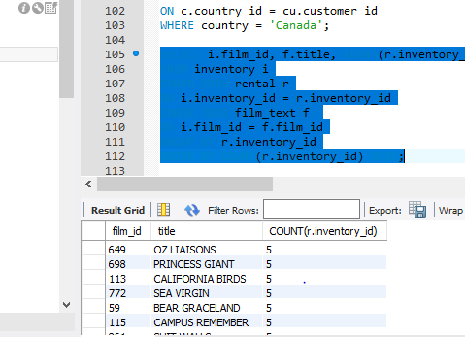

-- 7f. Write a query to display how much business, in dollars, each store brought in.

SELECT store.store_id, SUM(amount)

FROM store

INNER JOIN staff

ON store.store_id = staff.store_id

INNER JOIN payment p

ON p.staff_id = staff.staff_id

GROUP BY store.store_id

ORDER BY SUM(amount);

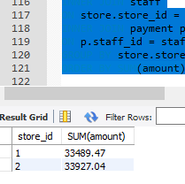

-- 7g. Write a query to display for each store its store ID, city, and country.

USE Sakila;

SELECT s.store_id, city, country

FROM store s

INNER JOIN customer cu ON s.store_id = cu.store_id

INNER JOIN staff st ON s.store_id = st.store_id

INNER JOIN address a ON cu.address_id = a.address_id

INNER JOIN city ci ON a.city_id = ci.city_id

INNER JOIN country coun

ON ci.country_id = coun.country_id

WHERE country like 'CANADA%' AND 'AUSTRAILA%';

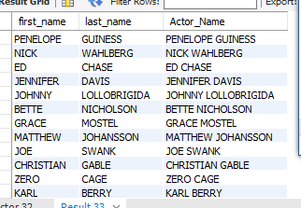

-- 7h. List the top five genres in gross revenue in descending order. (Hint: you may need to use the following

-- tables: category, film_category, inventory, payment, and rental.)

select sum(payment.amount)as 'sales', category.name

from payment join rental on (rental.rental_id= payment.rental_id)

join inventory on (inventory.inventory_id = rental.inventory_id)

join film_category on (film_category.film_id = inventory.film_id)

join category on (category.category_id = film_category.category_id)

group by category.name

order by sum(payment.amount)desc

limit 5;



-- 8a. In your new role as an executive, you would like to have an easy way of

-- viewing the top five genres by gross revenue. Use the solution from the

-- problem above to create a view. If you haven't solved 7h, you can substitute

-- another query to create a view.

create view top5 as

select sum(payment.amount)as 'sales', category.name

from payment join rental on (rental.rental_id= payment.rental_id)

join inventory on (inventory.inventory_id = rental.inventory_id)

join film_category on (film_category.film_id = inventory.film_id)

join category on (category.category_id = film_category.category_id)

group by category.name

order by sum(payment.amount)desc

limit 5;

-- 8b. How would you display the view that you created in 8a?

create view top_five_genres as

select sum(payment.amount)as 'sales', category.name

from payment join rental on (rental.rental_id= payment.rental_id)

join inventory on (inventory.inventory_id = rental.inventory_id)

join film_category on (film_category.film_id = inventory.film_id)

join category on (category.category_id = film_category.category_id)

group by category.name

order by sum(payment.amount)desc

limit 5;

-- 8c. 8c. You find that you no longer need the view `top_five_genres`. Write a query to delete it.

DROP VIEW top_five_genres;

### Appendix: List of Tables in the Sakila DB

* A schema is also available as `sakila_schema.svg`. Open it with a browser to view.

```sql

'actor'

'actor_info'

'address'

'category'

'city'

'country'

'customer'

'customer_list'

'film'

'film_actor'

'film_category'

'film_list'

'film_text'

'inventory'

'language'

'nicer_but_slower_film_list'

'payment'

'rental'

'sales_by_film_category'

'sales_by_store'

'staff'

'staff_list'

'store'

```